Objectives:

* Task 1: Deploy a Docker image by using the Azure Container Instance
* Task 2: Review the functionality of the Azure Container Instance

Architecture diagram:

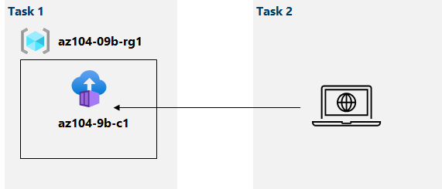

Task 1: Deploy a Docker image by using the Azure Container Instance.

In this task, we will create a new container instance for the web application:

After following the steps, we create a new container like below:

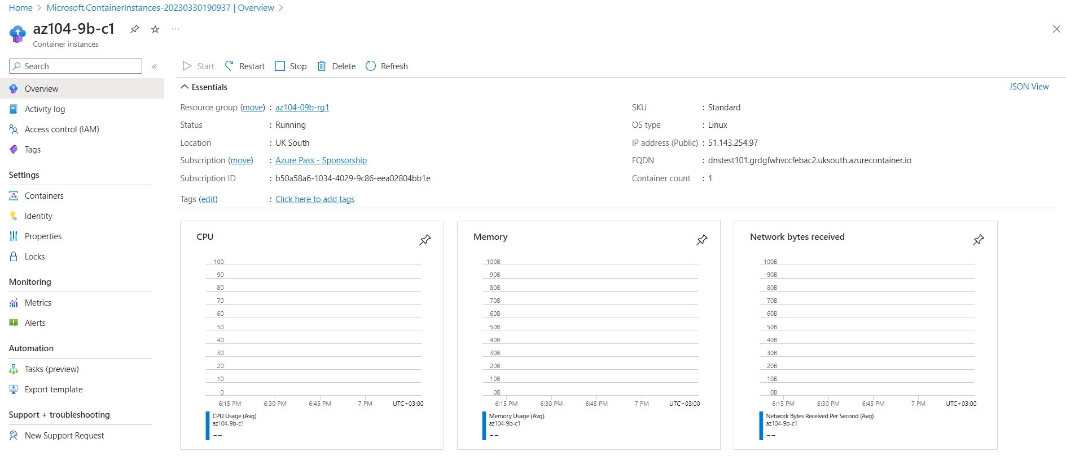

Task 2: Review the functionality of the Azure Container Instance.

In this task, we will review the deployment of the container instance:

Here, we copy the FQDN value that we can also see on the screenshot above, open up a new tab and verify that the correct page is displayed:

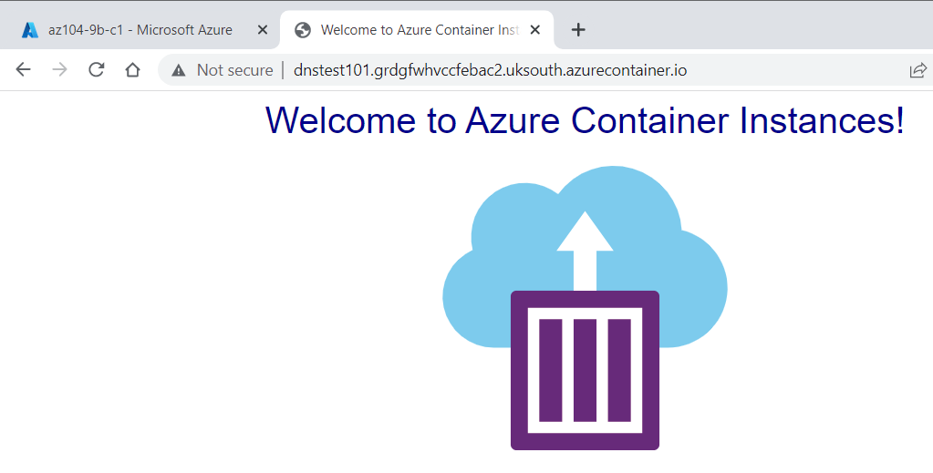

After this, we go to the Settings section of the container -> Containers -> Logs and we can see the log entry that represents the HTTP GET request:

